sOFTWARE 1 PRACTICAL

## Loops & Functions

Week 4 – Practical 5

Exercise 1: *The King and the Wise man*

When the creator of the game of chess showed his invention to the ruler of the country, the ruler was so pleased that he gave the inventor the right to name his prize for the invention. The man, who was very wise, asked the king this: that for the first square of the chess board, he would receive one grain of wheat (in some telling, rice), two for the second one, four on the third one, and so forth, doubling the amount each time. The ruler, arithmetically unaware, quickly accepted the inventor's offer, even getting offended by his perceived notion that the inventor was asking for such a low price and ordered the treasurer to count and hand over the wheat to the inventor. Given that the chessboard is a $8×8$ board and given the weight of a single grain of rice is about 30 mg, calculate the total weight of rice the king must give to the wise man. The program should print the weight of rice for each chessboard square.

Exercise 2: *from a resit paper.*

You must use the file practical_5.py to answer this question. Write a function get_words_starting_with(text, letter) that returns the list of words starting with letter in the string text. The result should not be case sensitive, e.g. ’about’ should be returned if the letter ’a’ or ’A’ is given as parameter. For simplicity, we assume for exercises 2,3, and 4 that the text does not have any punctuations, and words are separated by at least one blank space.

For example, using the variable sample_text we should obtain:

>>> get_words_starting_with (sample_text, ’a’)

[’As’, ’a’, ’about’, ’adding’, ’a’, ’ago’, ’a’,

’around’, ’Amsterdam’, ’a’, ’and’, ’an’, ’about’,

’a’, ’ABC’, ’appeal’, ’as’, ’a’, ’a’, ’a’]

>>> get_words_starting_with(sample_text, ’z’)

[]

**Hint:** You may want to use the method split() from the str type.

Exercise 3: *from a resit paper.*

As you can see in question 2, there are many repetitions of the word ’a’ in the list. Improve your solution so no repetition of the same word occurs in the list.

>>> get_words_starting_with(sample_text, ’a’)

[’As’, ’a’, ’about’, ’adding’, ’ago’, ’around’, ’Amsterdam’, ’and’, ’an’, ’ABC’, ’appeal’, ’as’]

Exercise 4: *difficult.*

Rather than just removing duplicate words like in question 3, perhaps it would be more interesting to keep track of the number of occurrences of each word. For example, in sample_text, ‘a’ occurs 9 times, while ‘as’ occurs twice (one ‘As’ and one ‘as) and ‘python’ three times.

Implement get_words_frequencies(text)which returns the result of our computation, that is for each word in text, provide its number of occurrences in text. What kind of data structure would you use to represent the result of the computation? Compare your solution with someone else, are they similar? If not, which one is best, and why?

Exercise 5: *Cryptography, Caesar Cipher*

In cryptography, a **Caesar cipher**, also known as the shift cipher, is one of the simplest and most widely known encryption techniques. It is a type of substitution cipher in which each letter in the plain text is replaced by a letter some fixed number of positions down the alphabet.

For example, with a shift of 3, A would be replaced by D, B would become E, and so on. The method is named after Julius Caesar, who used it to communicate with his generals.

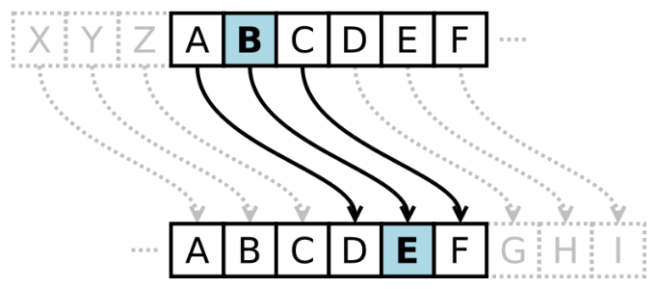Mathematically, a Caesar cipher can be expressed by the following equation:

*c = (p + a) mod 26*

Here, ‘mod 26’ means that you use clock arithmetic for values greater than 26, i.e., 0=26 mod 26, 1=27 mod 26, 2=28 mod 26, …, 0=52 mod 26, 1=53 mod 26, …, 10=62 mod 26, and so on.

1. Write a function caesar_encrypt that encrypts a plain text into a cypher text using the Caesar Cipher algorithm. What parameters are needed? Should the function return something? For simplicity, assume that only alphabet letters are encrypted, other symbols remain the same.
2. Write a function caesar_decrypt that decrypts a cipher text into a plain text using the Caesar Cipher algorithm. What parameters are needed?
3. Given the cipher text below, and knowing it has been encrypted using a Caesar Cipher algorithm, could you decrypt it?

"bpm owwl vmea ijwcb kwuxcbmza qa bpib bpmg lw epib gwc bmtt bpmu bw lw. bpm jil vmea qa bpib bpmg lw epib gwc bmtt bpmu bw lw.”

Exercise 6: *Vectors*

A vector of dimension $n$ can be represented by a list in Python. For example, a vector of dimension 3 could represent a point in space, and a vector of dimension 4 could represent a point in space and time (the fourth dimension being the time). In mathematical notation, a vector of dimension 3 is represented as follow:

$$\left[\begin{matrix}a \\ b \\ c\end{matrix}\right]$$

The vector could be stored in a Python list [a, b, c]. There are two simple operations that can be done on vector, and the result of the two operation is also a vector. The two operation s are:

Scalar product: $λ ∙ \left[\begin{matrix}a \\ b \\ c\end{matrix}\right]= \left[\begin{matrix}λ∙a \\ λ∙b \\ λ∙c\end{matrix}\right]$

Addition: $\left[\begin{matrix}a \\ b \\ c\end{matrix}\right]+\left[\begin{matrix}d \\ e \\ f\end{matrix}\right]= \left[\begin{matrix}a+d \\ b+e \\ c+f\end{matrix}\right]$

Create two functions:

1. scalar_product(scalar, vector) where scalar is a float and vector is a list of float. The function returns the scalar product of the two parameters.
2. vector_addition(vector1, vector2) where vector1 and vector2 are lists of float. The function returns the vector addition of the two parameters. If vector1 and vector2 don’t have the same dimension, you should print an error message.